Product Recommender System Using NLP & Deep Learning
DSCI-590: Introduction to NLP for Data Science; Fall 2025; Taught by Professor Olga Scrivner
Team Members: Owen Randolph, Laine Close, Marcos Fernandez
- Purpose & Audience
Recommender systems are widely used across digital platforms where user choice is central. They benefit both users and creators by improving discovery, increasing engagement, and driving higher conversion rates. A well-known example is Amazon’s recommendation engine, which has significantly boosted user interaction and overall spending on its platform. For customers, these systems enhance the shopping experience by presenting products that align with personal preferences—whether inferred from individual browsing behavior or derived from broader popularity patterns. As a result, recommender systems have fundamentally reshaped the way users discover and interact with products online.
In this project, the intended audience for the recommender system includes both end users who seek personalized product suggestions and the platform owners who benefit from improved user engagement and decision support.
- Model Architecture and Features

  - NoSQL Database
Our first task was to load the dataset into a document-oriented database, as the data was provided in JSON format. Because the dataset contains semi-structured text and tens of millions of records, a flexible NoSQL system was required.
MongoDB Database
MongoDB is a powerful platform for managing NoSQL document-based databases. The cluster used in this project is hosted on MongoDB Atlas and runs on three AWS EC2 nodes, providing scalability and optimized performance. These compute nodes allow efficient querying and data extraction, even for very large datasets, in our case, approximately 24 million documents. This distributed setup enables MongoDB to handle big data management and high-volume data transfer effectively.
Unlike relational databases, MongoDB is nonrelational and stores data in a flexible, document-oriented format. Because our datasets contain long strings of text (such as user reviews and product descriptions), this data model is the most suitable choice. The data is stored in JSON Lines (JSONL) format, representing semi-structured, raw text data, which can be efficiently indexed and queried for analysis.
MongoDB Compass
MongoDB Compass is used to upload and inspect the datasets within the project’s MongoDB Atlas cluster. It provides a graphical interface for viewing documents, running queries, and exploring data structures stored in each collection.
In this project, Compass was used to verify that the merged datasets were successfully imported into the amazon_reviews database and stored under the “Electronics” collection. This interface also allowed the team to preview individual records.
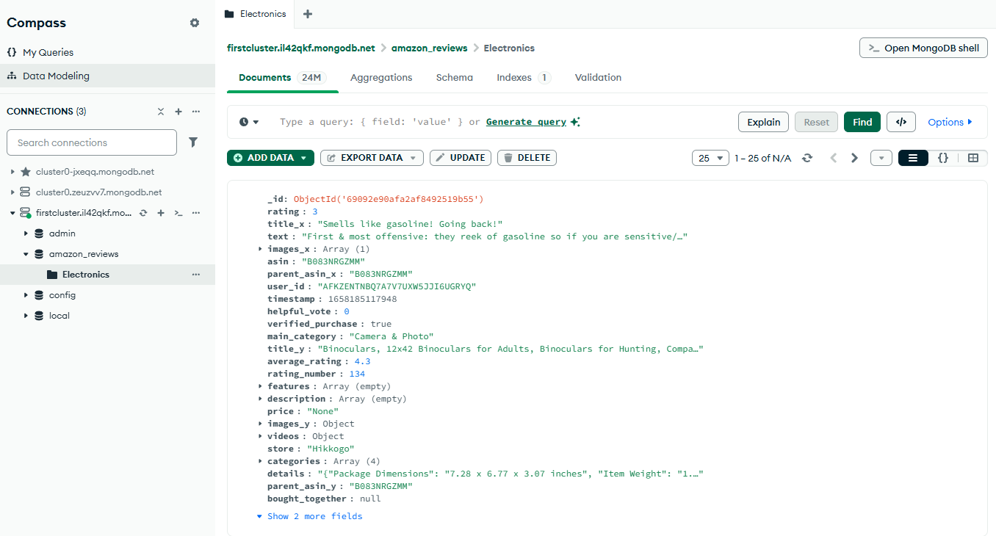
Data Integration
The two datasets, Electronics.jsonl.gz (containing user reviews) and meta_Electronics.jsonl.gz (containing product metadata), were merged using an inner join on the shared key asin (Amazon Standard Identification Number). The merge operation was performed in Python using pandas to ensure that only products appearing in both datasets were retained in the final dataset. The resulting merged dataset was then stored in MongoDB Atlas as the collection “Electronics” within the amazon_reviews database. A collection functions as a dataset in a document-oriented database, similar to a table in a relational database.
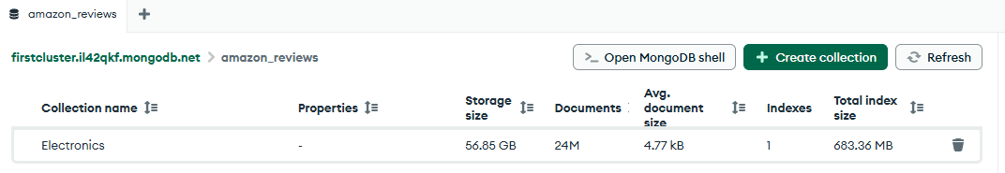

Database Engine
MongoDB Atlas is used as the cloud-based GUI for our NoSQL document database. Users can manage clusters, monitor, scale, and configure their deployments on this web console.

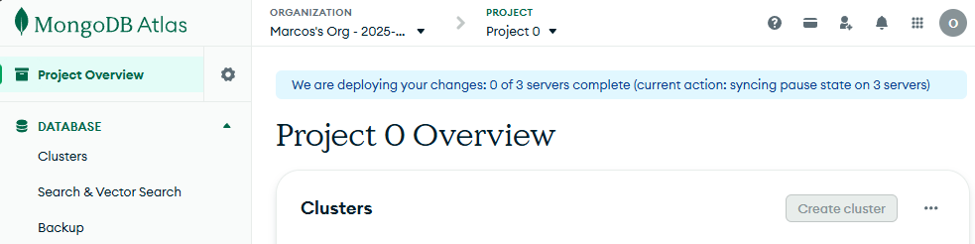
  - Data Preprocessing: Text Cleaning
The rest of this project was built using Python, starting with loading the data from the MongoDB database and into a Jupyter notebook. After loading libraries and data, we continued by removing English stop words and HTML or special character artifacts (e.g., “nbsp”), and tokenizing the text into manageable word units for later feature extraction and embedding.

2.3 Feature Extraction & Collaborative Filtering Model
In this stage, we generate BERT embeddings to convert product descriptions and review text into dense numerical vectors. These embeddings capture the underlying semantic meaning of the language, enabling the recommender system to compare products based on contextual similarity rather than relying on simple keyword matching.
The textual BERT embeddings are then complemented by a collaborative filtering module, which learns latent factors for users and items from historical ratings. While BERT captures semantic meaning from product descriptions, collaborative filtering captures behavioral patterns such as user preferences and item co-occurrence trends. Together, these components form a hybrid recommender system that integrates language understanding with interaction-based learning.

2.4 App Architecture

2.5 Literature Consulted for Architecture

3. Functionalities
This section describes the core functionality of the recommendation engine. After preprocessing and feature extraction, the system uses user–item embeddings to compute personalized product recommendations. The functionality is implemented in several steps that map user data, filter previously interacted items, compute scores with the trained model, and return the top-ranked results.
3.1 User–Item Index Mapping
To ensure efficient model evaluation, the system converts user IDs and item IDs into continuous numerical indices. These mappings allow fast lookup during inference, link raw IDs to embedding positions, and ensure consistent alignment between the database, the preprocessed DataFrame, and the PyTorch model.
Mappings include:
- user_id_to_idx: converts external user IDs into internal user embedding indices
- idx_to_title: maps each item index to its human-readable product title for display
This allows recommendations to be made using compact numerical representations while still presenting meaningful product titles to the user.
3.2 User Purchase History Filtering
The system constructs a dictionary of user-rated or user-purchased items by grouping preprocessed data on user_idx.
This functionality ensures:
- the model does not recommend items the user has already interacted with,
- recommendations remain novel and meaningful, and
- evaluation loops avoid redundant computation.
The history is stored as a Python set for constant-time lookup.
3.3 Recommendation Function: recommend_top_n_cf()
The main inference logic is implemented in the recommend_top_n_cf() function.
Model Evaluation Mode
The function switches the PyTorch model to eval() mode, disabling dropout and gradient updates. This ensures stable and deterministic predictions.
Input Validation
If the provided user_id is not found in the mapping, the function returns an informative message. This prevents runtime errors and improves robustness.
Score Computation
For each candidate item:
- previously rated items are skipped,
- the model receives the (user_idx, item_idx) pair,
- the forward pass computes a recommendation score,
- the score is stored along with the item index.
Scores are computed inside torch.no_grad() to improve efficiency and reduce memory usage during inference.
3.4 Ranking and Output
All candidate items are sorted by score in descending order.
The function returns the top N recommended items, printing each product’s title using the idx_to_title mapping.
This produces final user-friendly output:
“Top 5 recommended products for user X:” followed by their predicted best-matching items.

Link to App & GitHub Repo

https://github.com/orandolph8/DSCI-590-NLP-Final-Project
Issues/Contributions
  - Describe the most challenging part for the team
  - Describe the part that you are most proud of learning in this project
  - Add summary of work/contributions by each team member
References

McAuley, J. (2023). Amazon Reviews 2023 Dataset. Hugging Face.
Retrieved from https://huggingface.co/datasets/McAuley-Lab/Amazon-Reviews-2023

Codegenes. (n.d.). Collaborative Filtering Using PyTorch.
Retrieved from https://www.codegenes.net/blog/collaborative-filtering-pytorch/

GeeksforGeeks. (n.d.). Build a Recommendation Engine with Collaborative Filtering.
Retrieved from https://www.geeksforgeeks.org/machine-learning/build-a-recommendation-engine-with-collaborative-filtering/

PyTorch. (n.d.). Introducing TorchRec.
Retrieved from https://pytorch.org/blog/introducing-torchrec/

Sling Academy. (n.d.). Combining Content-Based and Collaborative Approaches in PyTorch Recommenders.
Retrieved from https://www.slingacademy.com/article/combining-content-based-and-collaborative-approaches-in-pytorch-recommenders/

PyTorch Documentation. (n.d.). Data API Reference.
Retrieved from https://docs.pytorch.org/docs/stable/data.html

Appendix
Dataset Information
Each “category” contains two JSON files. For appliances, these are the files:
Type | File Name | What It Contains | Size (approx)
Review data | Electronics.json.gz | 2 million+ User reviews (ratings, text, timestamps, user_id, asin) | 258 MB
Metadata | meta_Electronics.json.gz | 93,000+ Product info (titles, categories, brands, prices, descriptions) | 63.3 MB

Json file features example from user review dataset (Electronics.json.gz):

Field | Description | Example / Interpretation
"rating" | The star rating (1.0–5.0) | 5.0 → extremely satisfied
"title" | Short summary or headline of the review | "The hardest part is pulling(disconnecting & reconnecting) dishwasher"
"text" | The main body of the review | "Love this because it's the complete assembly"
"images" | List of review images (if any) | [] → no uploaded photos
"asin" | Amazon Standard Identification Number (unique product ID) | "B07B4MSV7J"
"parent_asin" | Grouping ID (same for product variations) | "B07B4MSV7J" (identical, meaning this product has no variations or this review applies to the main listing)
"user_id" | Unique reviewer identifier | "AEUL23LUBSPLLOKANUHAUY37SG5A"
"timestamp" | Time of review in Unix epoch (milliseconds) | 1565982989421 → corresponds to Aug 16, 2019, 16:16:29 UTC
"helpful_vote" | How many people marked it as helpful | 0 → no votes
"verified_purchase" | Whether the reviewer actually bought the product | true → verified customer

Data example from product info dataset (meta_Appliances.json.gz
):

Field | Meaning | Example / Use
"main_category" | Broad department the product belongs to | "Tools & Home Improvement" — useful for category-based filtering
"title" | Product name | "Agitator Cam Kit W/ Dogs for Whirlpool Sears Kenmore 285748 3347085"
"average_rating" | Mean star rating across all users | 4.1
"rating_number" | Total number of ratings | 34
"features" | Bullet-point product highlights | ["Agitator Cam Kit", "285748"] — could feed into NLP embeddings
"description" | Text description | "Appliance Replacement Part ER285748" — can be tokenized for content similarity
"price" | Product price | null (missing here, but normally numeric)
"images" | Image URLs | You can embed or use CNN-based vision embeddings for multimodal recommendations
"store" | Seller or brand | "Whirlpool"
"categories" | Full taxonomy hierarchy | ["Appliances", "Parts & Accessories", "Dryer Parts & Accessories", "Replacement Parts"]
"details" | Manufacturer specs | Manufacturer, weight, dimensions, etc.
"parent_asin" | Identifier for grouped variations | "B00U1SCKNQ" — links to variations like color/size
"bought_together" | Amazon’s own co-purchase data | null here, but usually includes “Customers also bought…” info

